**PHANTOM**

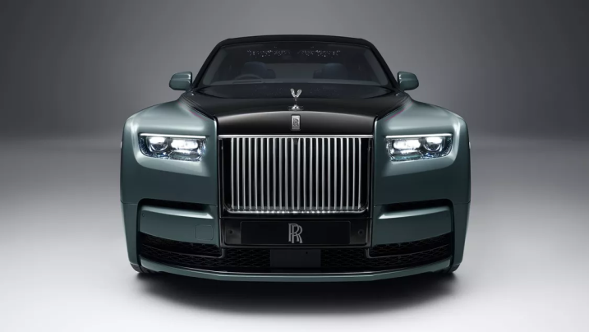

THE ILLUMINATED GRILLE

Amplified by a Dark Chrome Surround, the legendary Rolls-Royce Pantheon Grille now radiates a stunning glow. Above, a polished bar perfectly aligns with new Daytime Running Lights, creating a prominent and powerful horizon line.

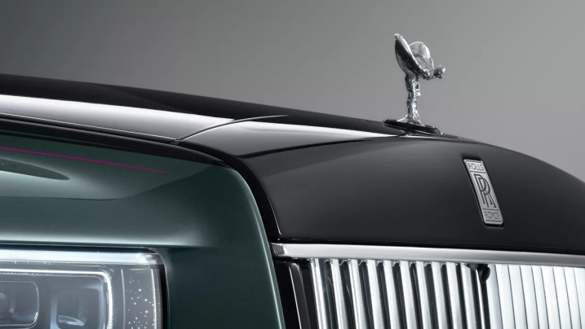

AN EVERLASTING MUSE

The famed Spirit of Ecstasy proudly adorns the bonnet of Phantom Series II, denoting it a rightful icon. She lights the way with graceful power in a stance of eternal flight.

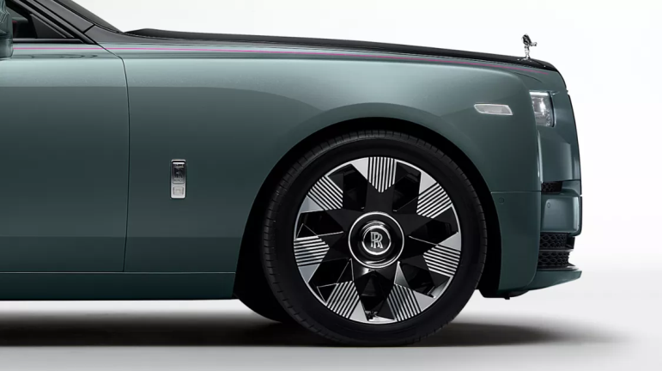

STRIKING WHEEL DIMENSIONS

Manufactured by 3D milling, the Dynamic Wheel’s faceted surface creates an abstract sense of depth. When in motion, the esteemed Rolls-Royce monograms remain centred, poised, and set in place.

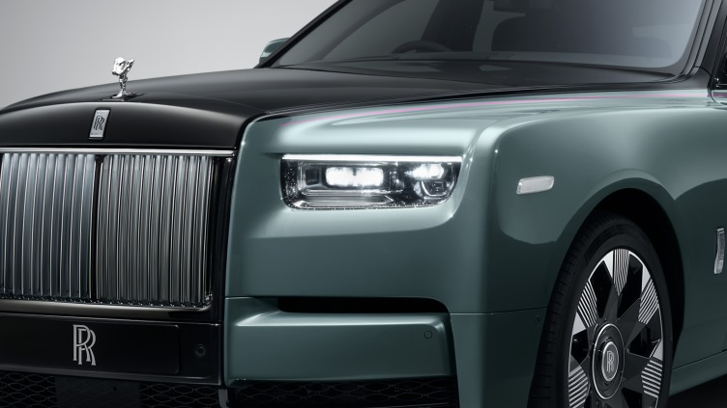

A hand-painted Peony Pink Coachline is flawlessly set against the distinctive Monteverde exterior — a colour inspired by the green and blue hues of nature’s undiscovered territories, enlivened by gleaming golden pearl.

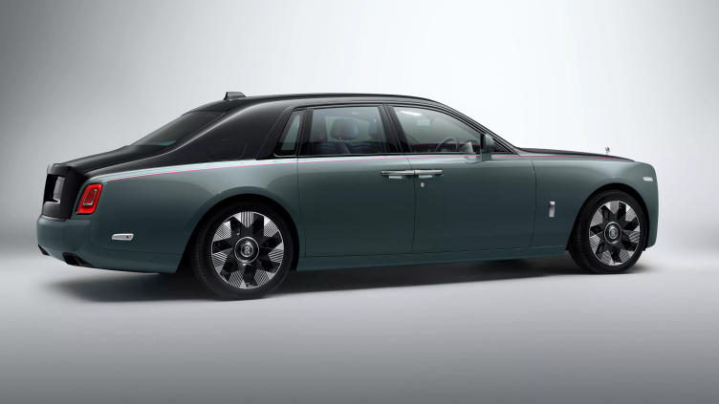

In impressive Two-Tone Paint, Phantom Series II stands out against the crowd. Complementing colour schemes accentuate its muscular lines, drawing owners to the driver’s seat.

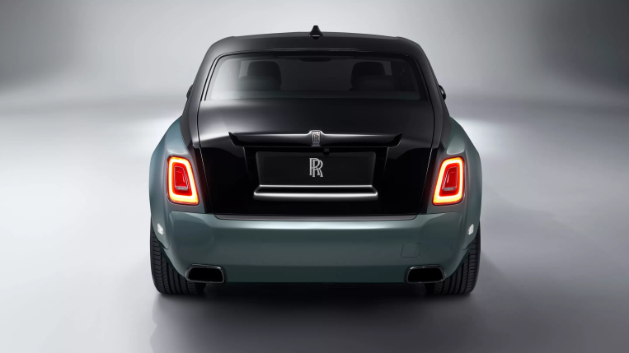

Enhanced Exterior Black Detailing, such as dark windscreen, taillight, and exhaust surrounds, serve to embolden the motor car’s athletic stature.

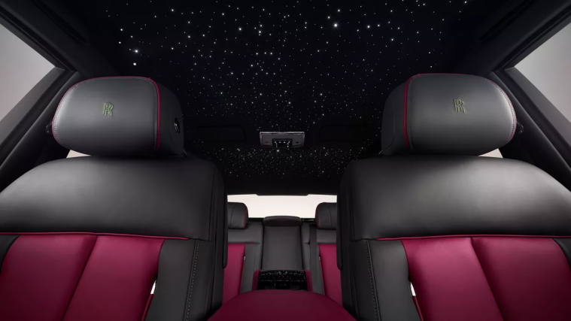

EXPLORE THE NIGHT SKY

The transfixing Shooting Star Headliner is made from hundreds of fibre-optic lights delicately fitted into the leather roof lining. Owners can personalise their celestial canopy with unique colours and custom constellations.

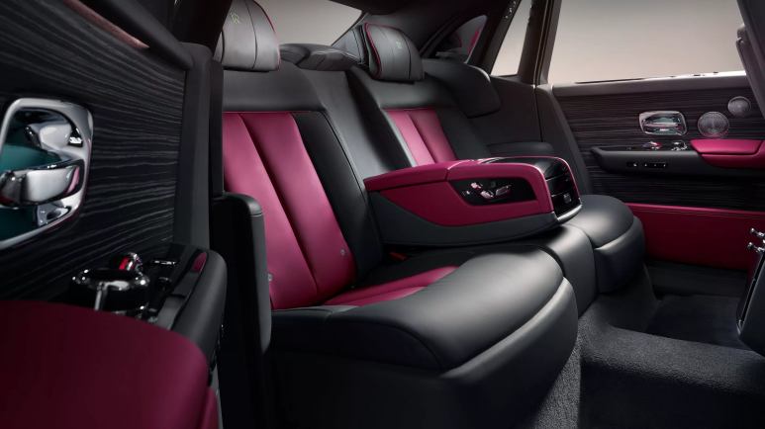WORLD-CLASS MATERIALS

Scivaro Grey and Peony Pink leather cushions you in pure comfort. Through an intensive selection and refinement process, only the world’s finest leather is sewn into this icon

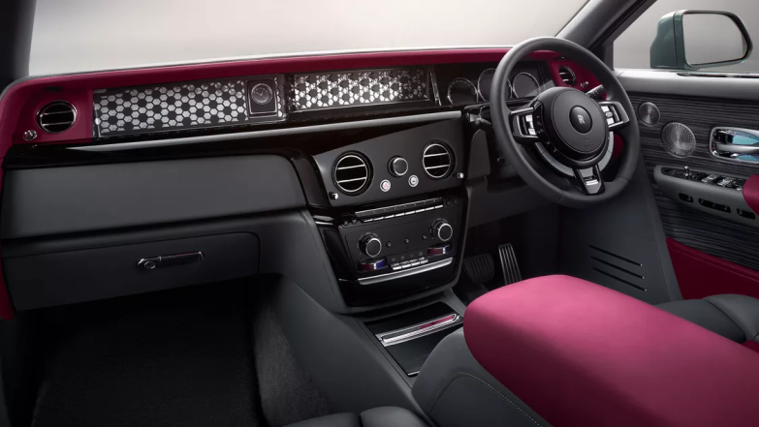

UNDER YOUR CONTROL

The optional Thick Steering Wheel is the ultimate point of connection between driver and motor car. From this unique position, owners take charge of the road cosseted in refined luxury.

STAY CONNECTED

Access personalised car data and insights with *Rolls-Royce Connected. Available exclusively through Whispers, our owners-only app.

Locate your Rolls-Royce motor car, review its health status, receive helpful maintenance reminders, and send suggested Whispers locations, such as restaurants and dealerships, directly to your car for seamless navigation.

*Available in selected markets only. For further details, please contact your local dealerships.

**SPECTRE**

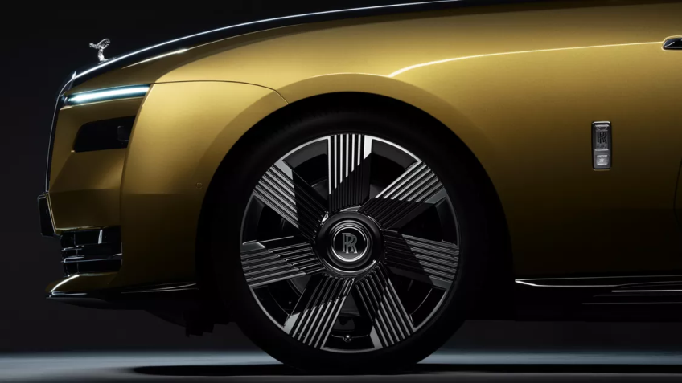

FORMIDABLE WHEELS

Spectre’s Architecture of Luxury — a bespoke aluminium space-frame underpinning the model — now fits 23” wheels for the first time. The effect is impressive from an aesthetic and performance perspective. For drivers who find themselves upon icy, snow-covered surfaces, coupling the wheels with winter tyres is relished.

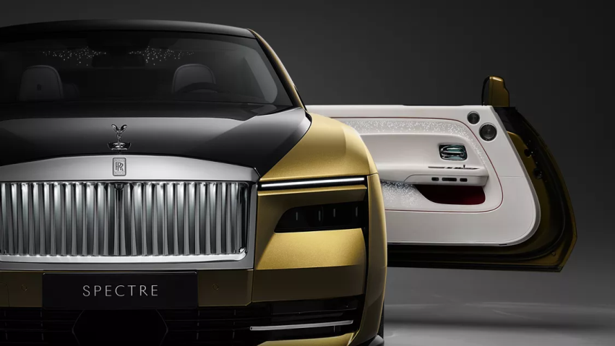

EFFORTLESS DOORS

Spectre’s doors are the largest of any Rolls-Royce, measuring 1.5 metres in length. Their generous size makes the act of entering and exiting the motor car a graceful act. Open and close them with the touch of a button. Think of their effortless technology as a built-in chauffeur, always on hand and at your perennial service.

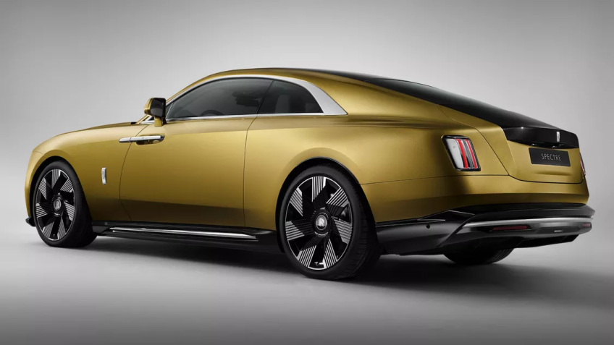

SPIRITED COLOUR

Spectre presents a never-before-seen exterior colour option, Chartreuse — a vivid shade replicating the green tones of the French liqueur originally made by monks in the mountainous region of Grenoble, France. Like the liqueur, the hue boasts a mesmerising richness and depth, inviting the viewer’s eye to linger.

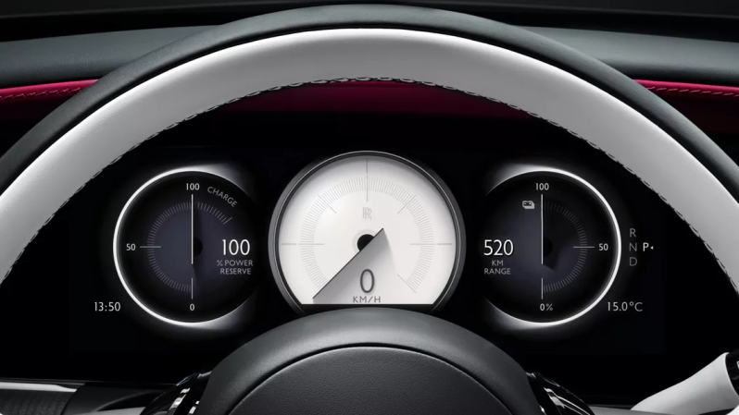BESPOKE INSTRUMENT DIALS

Seen for the first time on any Rolls-Royce, fully digital Bespoke Instrument Dials are a stunning display of technological craftsmanship, indicative of Spectre’s digital identity and the marque’s unparalleled design proficiency. Spectre owners may select a personalised and complementary dial colour upon commission. Modernising the view from the driver’s seat, the dials’ hands are decorated with a trail of brilliant stars — an enchanting celestial connection to the Starlight Doors, Starlight Headliner, and Illuminated Fascia.

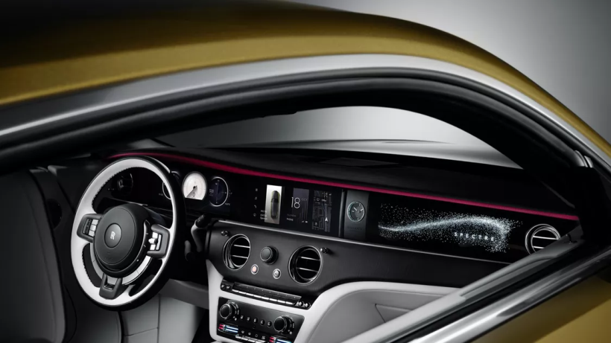

CONNECTED WITH WHISPERS

The Rolls-Royce experience extends beyond the physical drive. With Whispers, our owners-only app, drivers are always in tune with Spectre — the most connected Rolls-Royce yet. Once connected, drivers can send curated Whispers locations, such as restaurant recommendations, directly to the motor car for effortless navigation. Drivers can also discover their nearest charging station, precondition the interior to their optimal temperature, and securely lock and unlock Spectre from their mobile device.

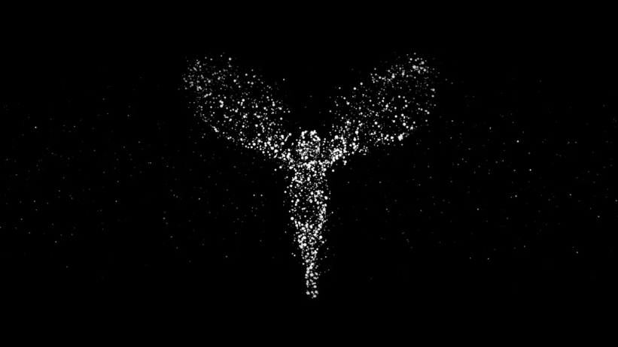

YOUR INTELLIGENT COMPANION

When driving Spectre, a range of needs may arise. Perhaps you may want the temperature adjusted, or require the whereabouts of your nearest charging station. Rather than acting upon these yourself, Eleanor, your intelligent companion, grants your requests.

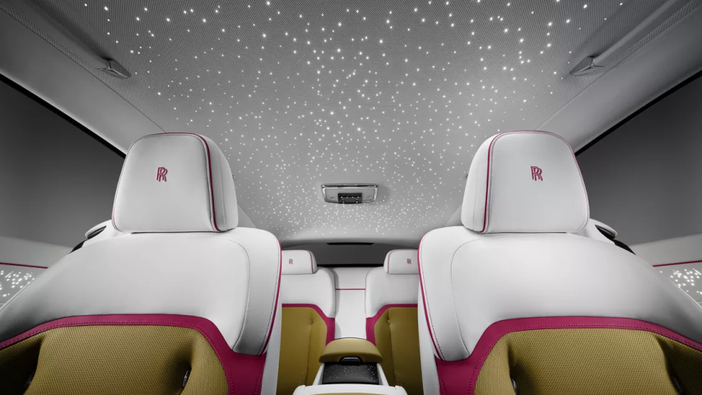

A CANOPY OF STARS

Rolls-Royce’s Starlight Headliner has been a statement feature since its 2007 debut, transfixing passengers with the atmospheric glow and hues of delicately placed fibre-optic lights. Ablaze with an intricate show of shooting stars, this stellar sky continues to shine for Spectre, remaining an iconic and timeless Rolls-Royce feature.

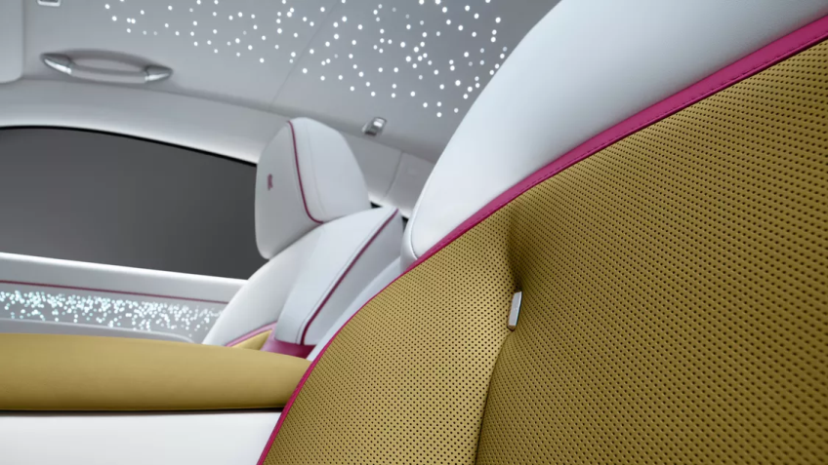PRISTINE LEATHER

Spectre’s distinct and supple leather is a result of intensive work done by Rolls-Royce’s own artisans and leather experts. Tumbling the hides in pigment gives them an intense colour payoff that permeates every level of the material, as opposed to just the top layer. This technique also ensures that over time, the leather ages beautifully and evenly.

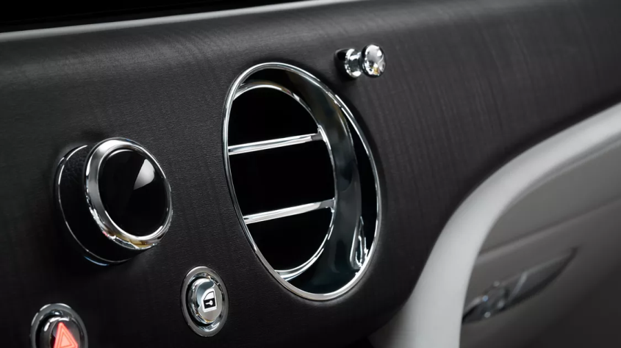

EXQUISITE WOODWORK

A Rolls-Royce craftsperson spends large stretches of time perfecting the smallest of details, informed by years of ardent training. Woodwork is no exception, with decorative pieces requiring an unwavering level of precision and skill. Interior open-pore veneer is testament to this. This particular option, Sindora, originates from Indonesia. The wood’s bold grain folds texture into the interior — balancing the clean, refined, and digitised surfaces found with the cabin.

**GHOST**

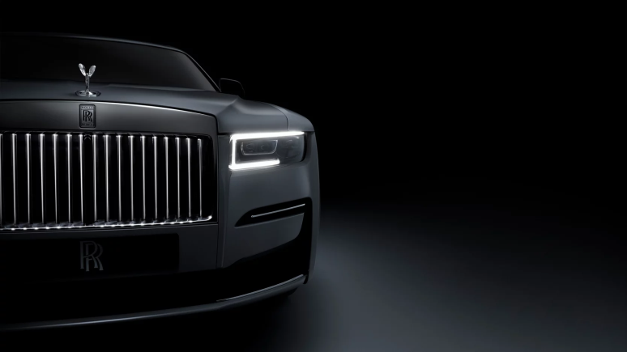

ILLUMINATED FROM WITHIN

In the dark of the night, the Illuminated Grille emits a divine glow, bestowing the car with a distinctive, 24-hour identity.

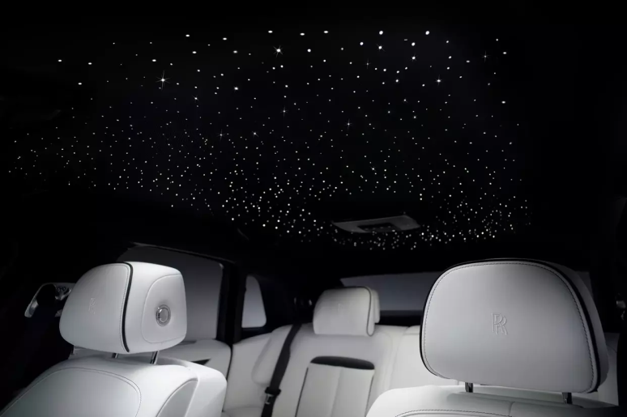

RADIANT BENEATH THE STARS

The Starlight Headliner is emphasised with an ephemeral show of shooting stars. The celestial scene is a rarefied vision of pure beauty.

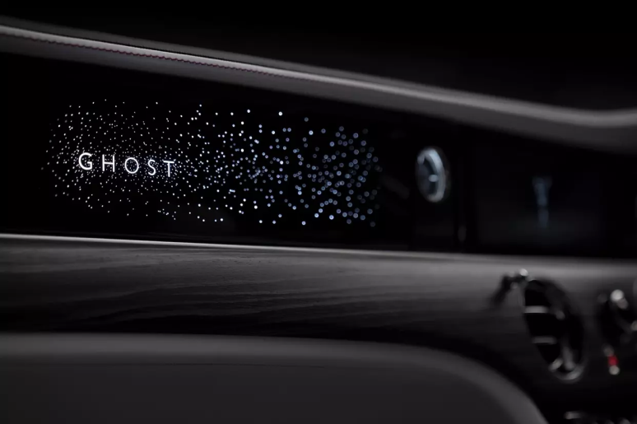

CAPTIVATING IN ESSENCE

The high-gloss, Illuminated Fascia is a masterful display of mesmerising craftsmanship. When Ghost is in motion, the wordmark is enlivened by the brilliance of 850 three-dimensional stars. When Ghost is in repose, the star field dims, and the fascia seemingly disappears into the abyss of the night.

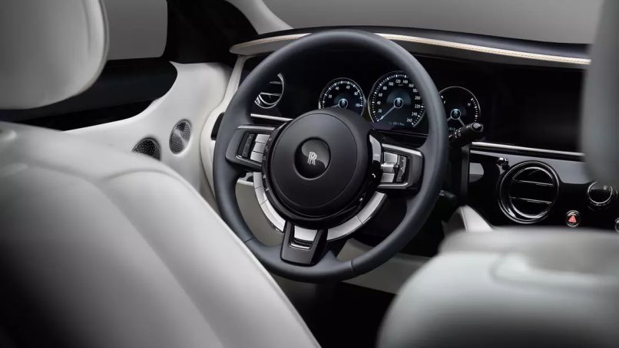

SUPERIOR DRIVING CAPABILITY

All-wheel drive establishes newfound versatility and on-road dynamism without compromising the Magic Carpet Ride.

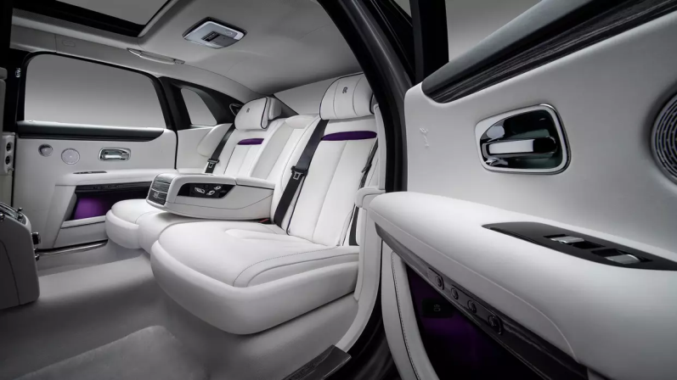

PURE SOUND, PURE SILENCE

The Bespoke Audio system is tailored to Ghost’s specific dimensions, creating studio-quality sound within the cabin. And because the aluminium Architecture of Luxury has high acoustic impedance, external noise is all but eliminated.

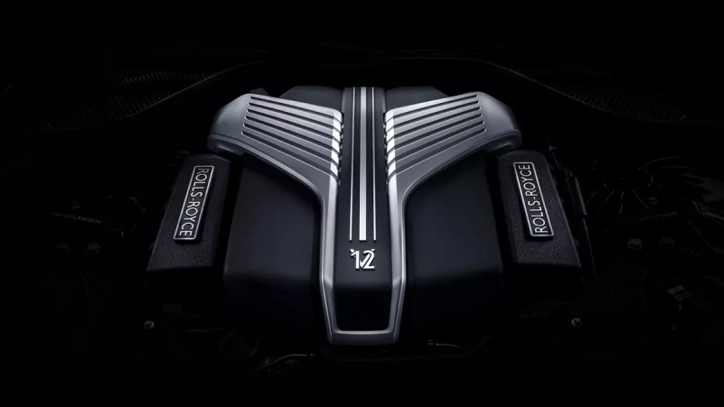

THE WORLD’S MOST REFINED ENGINE

Powered by the next generation 6.75-litre twin-turbocharged V12, delivering impressive torque at low RPM.

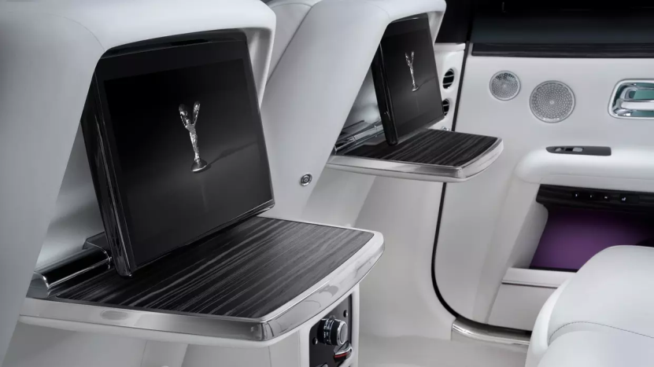

PERCEPTIVE TOUCHSCREENS

Responsive touchscreens on the front-central control display offer intuitive, expedient, and refined control.

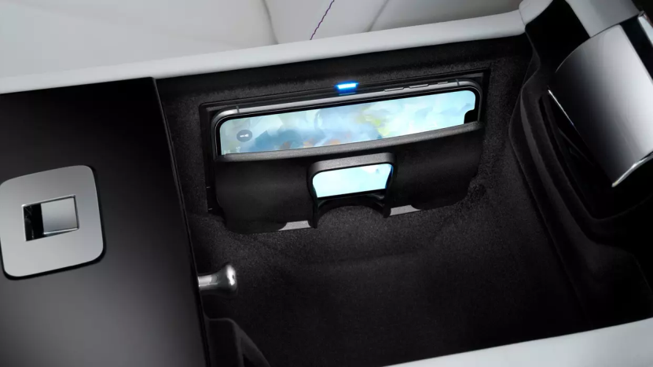

SEAMLESS CONNECTIVITY

Remain connected for professional or recreational purposes at all times with wireless charging, four USB-C ports, and Apple Car Play.

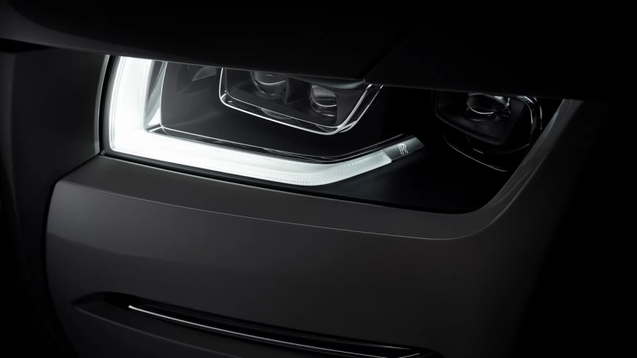

CRYSTAL CLEAR VISIBILITY

Laser headlights instil the driver with the utmost confidence, giving a visual range of up to 600m, twice the range of LED options, and ten times the intensity of conventional light sources.